Richard the Lionheart
The rebel behind the crown?
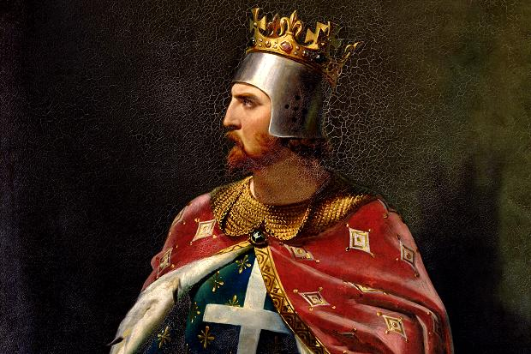

Richard the Lionheart, born September 8, 1157, showed signs of becoming a rebel early on. At age 16 he was commanding his own army and using it to fight rebellions against his father in Poitou. Such power should not be put into the hands of children. Not only did he rebel openly against his own father, our mighty leader—long live the king—but he sunk to the lowly state of a conspirator. The Lionheart went behind King Henry’s back and made secret deals with the French. Such things can only spell trouble. He even lived in France for most of his adult life, preferring to use his own kingdom only as a source of revenue to build up his armies.
Even though Richard was a central Christian commander during the Third Crusade, it was only a show of might and valor to win the love of his subjects. However, we cannot be fooled. England and France made a deal to both join the crusades only because they feared the other would invade their land while they were gone.
To build up his army, Richard spent most of his father’s treasury, increased taxes, and even released Scottish rebels for 10,000 marks. He sold the right to hold official positions, and those who were already appointed had to pay huge sums to keep their jobs. And though Richard won many victories against the Muslims, he failed in recapturing the Holy Land, and so all his crusade efforts were in vain anyway.
Richard the Lionheart is the reason that your funds have quickly been sucked up by greedy taxes, and your husbands, sons, and brothers have gone away to foreign lands to die far from their homes.

